Tech Saksham

Case Study Report

Data Analytics with Power BI

“Real – Time Analysis of Bank Customers”

“ NMS Sermathai vasan for women “

|  |  |
| --- | --- |
| NAME | NM ID |
| M.Vaitheeswari | 26B55A53237F054A41F4FF7583 |

Trainer Name :R.Umamaheswari

Master Trainer : R.Umamaheswari

**Introduction**

* 1. **problem statement**

In today’s competitive banking landscape, understanding customer behaviour and preferences is crucial for customer retention and revenue generation . However , banks often face challenges in analysing customer data due to the sheer volume and velocity of data generated. Traditional data analysis methods are time- consuming and often fail to provide real-time insights. This lack of real-time analysis can lead to missed opportunities for customer engagement, cross-selling, and up-selling, impacting the bank’s revenue generation and customer satisfaction. Furthermore, the complexity and diversity of customer data, which includes transaction history, customer feedback, and demographic data , pose additional challenges for data analysis.

* 1. **Proposed solution**

The proposed solution is to develop a power BI dashboard that can analyse and visualize real time customer data. The dashboard will integrate data from various sources such as transaction history, customer feedback, and demographic data.it will provide a comprehensive view of customer behaviour ,preferences, and trends, enabling banks to make informed decisions. The dashboard will be interactive, user-friendly, and customizable, allowing banks to tailor it to their specific needs. The real-time analysis capability of the dashboard will enable banks to respond promptly to changes in customer behaviour or preferences, identify opportunities for cross-selling and up-selling, and tailor their products and services to meet customer needs.

.

* 1. **Feature**
* Real-time Analysis : The dashboard will provide real-time analysis of customer data .
* Customer Segmentation: It will segment customers based on various parameters like age, income ,transaction behaviour ,etc.
* Trend Analysis: The dashboard will identify and display trends in customer behaviour.
* Predictive Analysis: It will use historical data to predict future customer behaviour .
  1. **Advantages**

* Data-driven Decisions: Banks can make informed decisions based on real-time data analysis.
* Improved customer Engagement :understanding customer behaviour and trends can help banks engage with their customers more effectively.
* Increased Revenue: By identifying opportunities for cross -selling and up-selling banks can increase their revenue.
  1. **Scope**

The scope of this project extends to all banking institution that aim to leverage data for decision-making and customer engagement. The project can be further extended to incorporate more data sources and advanced analytics techniques , such as machine learning and artificial intelligence , to provide more sophisticated insights into customer behaviour. The project also has the potential to be adapted for other sectors ,such as retail , healthcare ,and telecommunications , where understanding customer behaviour is crucial. Furthermore, the project contributes to the broader goal of digital transformation in the banking sector, promoting efficiency, innovation ,and customer centricity.

**SERVICES AND TOOLS REQUIRED**

**2.1 Services Used**

* Data collection and storage services : Banks need to collect and store customer data in real-time . this could be achieved through services like Azure Data factory, Azure event hubs, or AWS kinesis for real-time data collection, and Azure SQL data base or AWS RDS for data storage .
* Data processing services :Services like Azure stream analytics or AWS kinesis data analytics can be used to process the real-time data .
* Machine learning services : Azure machine learning or AWS sage maker can be used to built predictive models based on historical data .

**2.2. Tools and software used.**

TOOLS:

* Power BI: The main tool for this project is power BI, which will be used to create interactive dashboard for real-time data visualization.

.

* Power Query: This is a data connection technology that enables you to discover , connect, combine , and refine data across a wide variety of sources.

SOFTWARE REQUIREMENT:

* Power BI Desktop: This is a windows application that you can use to create report and publish them to Power BI .
* Power BI Service: This is an online SaaS (Software as a Service) Service that you use to publish report, create new dashboards , and share insights .
* Power BI Mobile : This is a mobile application that you can use to access your report and dashboard on the go.

**3.1 .HIGH – LEVEL ARCHITECTURE FOR THE PROJECT :**

1. **Data Collection** : Real-time customer data is collected from various sources like bank transaction , customer interaction , etc . This could be achieved using services like Azure events hubs or AWS kinesis .
2. **Data Storage**: The collected data is stored in a database for processing .Azure SQL database or AWS RDS can be used for this purpose .
3. **Data Processing** : The stored data is real-time using services like Azure stream analytics or AWS kinesis data analytics .
4. **Machine Learning** :Predictive models are built based on processed data using Azure machine learning or AWS sage marker .These models can help in predicting customer behaviour , detecting fraud , etc.
5. **Data Visualization** : The processed data and the result from the predictive models is visualized in real-time using BI. Power BI allows you to create interactive dashboard that can provide valuable insights into the data .
6. **Data Access** : The dashboards created in power BI can be accessed through power BI desktop , power BI service (online) , and power BI mobile .

This architecture provides a comprehensive solution for real-time analysis of bank customers. However , it’s important to note the specific architecture may vary depending on the bank’s existing infrastructure , specifics requirements , and budget .It’s also important to ensure that all tools all services comply with relevant data privacy and security regulations .

**Need to Implement Power BI Real-Time**

Power BI is primarily a decision-making tool that helps to extract valuable insights from the data. In the new age of analytics-driven decision-making, the one who has the latest data typically wins the market. There are also specific IOT-based requirements where Real-Time data must be analysed. In all these cases, Power BI’s Real Time data Streaming capability is a boon for organizations.

**DASHBOARD**

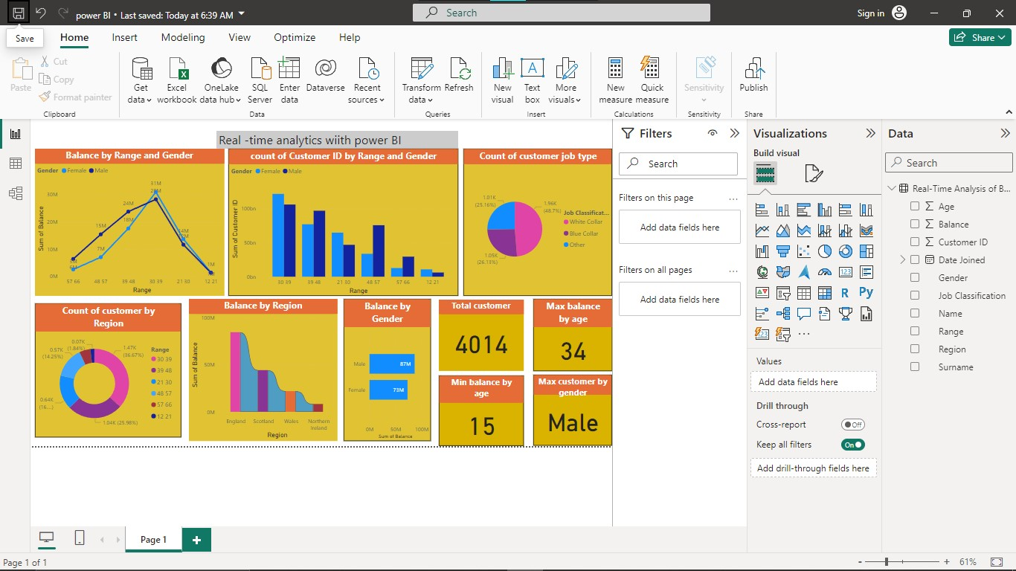

LINK:

<https://github.com/vaitheeswari2004/Real-time-analytics>